Volvo Bus Corporation
Press Information

Volvo 9700 celebrated as Coach of the Year 2008

With much pomp and ceremony, Volvo Buses’ President Håkan Karlsson received the impressive prize signifying that the Volvo 9700 was named Coach of the Year 2008. In his speech, Jury Chairman Stuart Jones praised the bus’s many positive features.

Volvo’s stand at the Busworld fair in Belgium was filled to the limit of capacity with customers, Volvo employees and other interested parties when it was time for the award ceremony. With a fanfare and a shower of gold confetti, the Volvo 9700 was unveiled, before Stuart Jones stepped to the podium.
“This year’s test attracted the biggest field of candidates in a decade. With such a strong line-up, it was going to take something special to emerge as a winner,” Stuart Jones said. “What won it for the Volvo 9700 wasn’t a single factor but a very solid all round performance with lots of positive points and virtually no negatives.”
He stated that the areas the jury members appreciated the most were passenger comfort, driver environment, driving performance, safety and design. “It’s a traveller’s coach” and “A super vehicle to drive – I was really impressed with it” were some of the opinions expressed by the jury members about the Volvo 9700.
In his acceptance speech, Håkan Karlsson said he was extremely pleased and proud about the prize. “When we started the project with the new Volvo 9700, we established a number of criteria we wanted to achieve – criteria adopted after discussions with our customers. It is extra pleasing that it was these areas the jury highlighted in its motivation.”

October 22, 2007
For further information, please contact Per-Martin Johansson, press officer, +46 31 322 52 00, per-martin.johansson@volvo.com

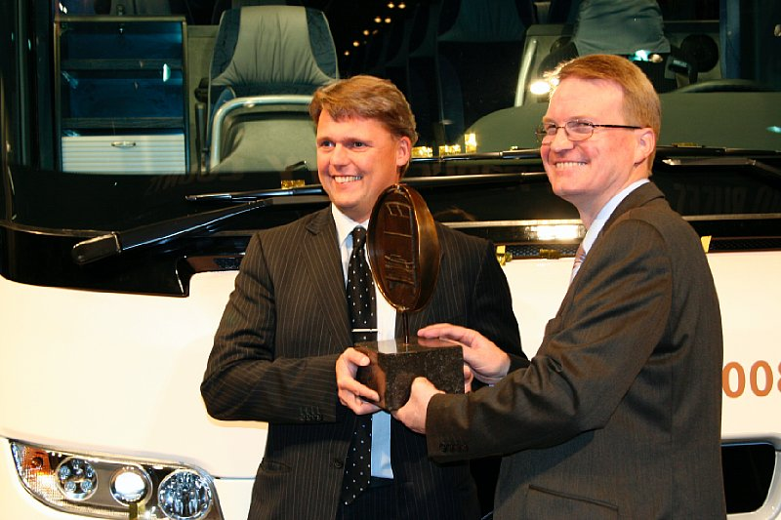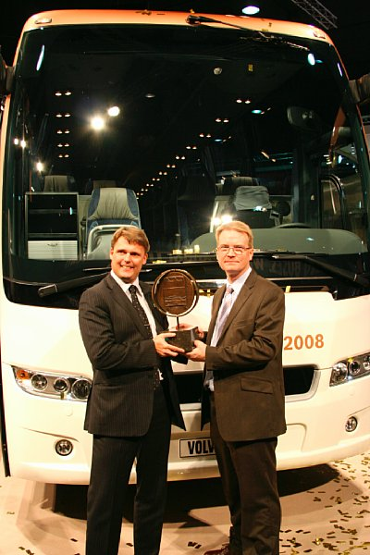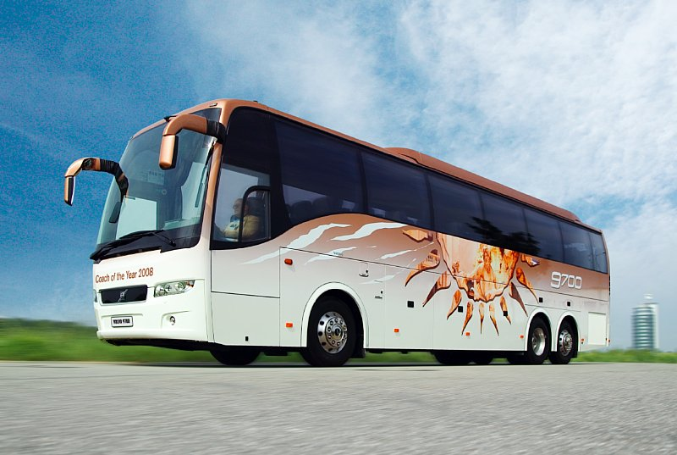
Download picture here Download picture Download picture

